**//even odd**

#include<stdio.h>

#include<conio.h>

void main()

{

int n;

clrscr();

printf("\nEnter a number");

scanf("%d",&n);

n%2==0?printf("Even number"):printf("Odd number");;

getch();

}

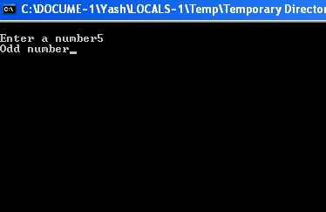

**//program to check a year is leap year or not**

#include<stdio.h>

#include<conio.h>

void main()

{

int year;

clrscr();

printf("\nEnter a year:\n");

scanf("%d",&year);

year%4==0 ? (year%100==0 && year%400==0 ? printf("\n%d is a leap year",year):printf("%d is not a leap year",year) ):printf("%d is not a leap year",year);

getch();

}

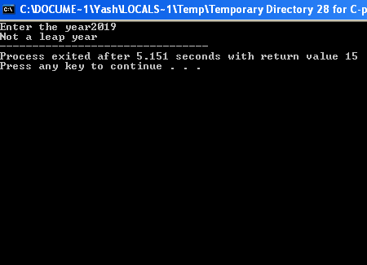

**//program to check if a given number is prime or not.**

#include<stdio.h>

#include<conio.h>

void main()

{

int n,i;clrscr();

printf("\nEnter a number:");

scanf("%d",&n);

for(i=2;i<=n-1;i++)

{

if(n%i==0)

break;

}

n==i?printf("\n%d is a prime number",n):printf("\n%d is not a prime number",n);

getch();

}

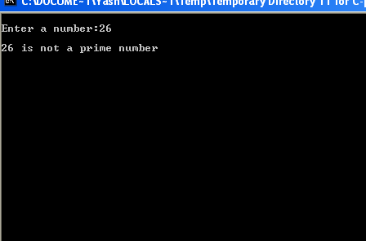

**//program to check if a given number is armstrong or not.**

#include<stdio.h>

#include<conio.h>

int main()

{

int num,num1,sum=0,rem;

printf("\nEnter a number:");

scanf("%d",&num);

num1 = num;

while (num != 0)

{

rem = num % 10;

sum = sum + (rem*rem*rem);

num = num / 10;

}

if(num1 == sum)

printf("\n%d is an Armstrong Number",num1);

else

printf("\n%d is not an Armstrong Number",num1);

return(0);}

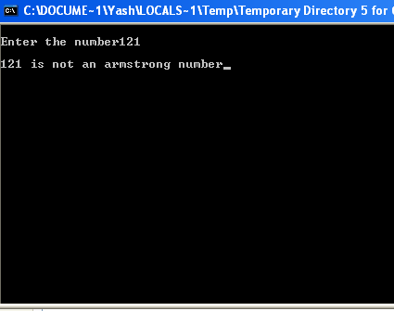

**//program to calculate the factors of a given number.**

#include<stdio.h>

#include<conio.h>

void main()

{

int n,i,facto;

clrscr();

printf("\nEnter the number");

scanf("%d",&n);

printf("\n**Factors are: ");

for(i=1;i<=n;i++)

{

if(n%i==0)

printf("%d\t",i);

}

getch();

}

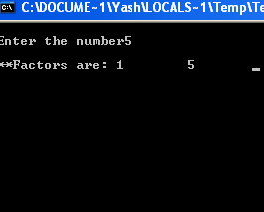

**//printing table**

#include<stdio.h>

#include<conio.h>

void main()

{

int n,i,res;

clrscr();

printf("\nEnter the number:");

scanf("%d",&n);

printf("\n**Table of %d**",n);

for(i=1;i<=10;i++)

{ res = n*i;

printf("\n%d * %d = %d\n",n,i,res);

}

getch();

}

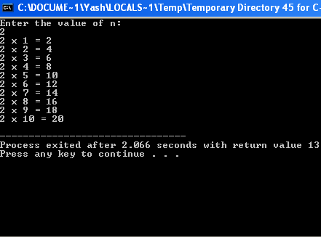

**//factorial**

#include<stdio.h>

#include<conio.h>

void main()

{

int n1,n,fact=1; clrscr();

printf("\nEnter the number: ");

scanf("%d",&n);

n1=n;

while(n!=0)

{

fact=fact*n;

n--;

}

printf("Factorail of %d = %d",n1,fact);

getch();

}

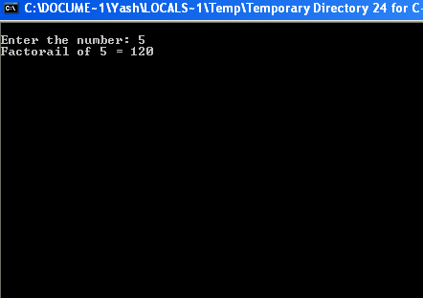

**//fibonacci**

#include<stdio.h>

int main()

{

int i,a=0,b=1,n,sum=0,s;

printf(“enter number of terms”);

scanf(“%d”,&s);

for(i=0;i<s;i++)

{

if(i<=1)

{n=i;}

else{n=a+b;

a=b;b=n;}

printf(“%d \t”,n);}return 0;}

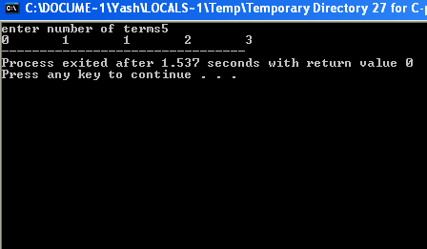

**//floyd triangle**

#include<stdio.h>

int main()

{

int m,k=1;

printf("enter number of rows you wanted");

scanf("%d",&m);

for(int i=1;i<=m;i++)

{

for(int j=1;j<=i;j++){

printf("%d ",k);

k++;

} printf("\n");}

return 0;

}

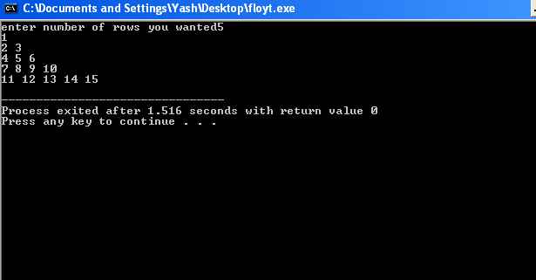

**//temp conversion**

#include<stdio.h>

#include<conio.h>

void main()

{

float t,conv;

int ch;clrscr();

printf("\nEnter the temperature:");

scanf("%f",&t);

printf("***Conversion***\n1.celsius to farenheit\t2.farenheit to celsius\n");

printf("Enter your choice(1-2)");

scanf("%d",&ch);

switch(ch)

{

case 1:conv = (1.8 * t) + 32;

printf("\n%f degree celsius = %f degree farenheit",t,conv);

break;

case 2:

conv = (t-32) * (5.0/9.0);

printf("\n%f degree farenheit = %f degree celsius",t,conv);

break;

default: printf("Wrong choice entered");

}

getch();

}

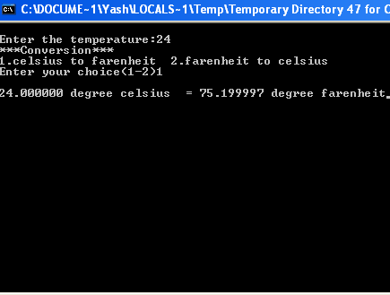

**//conversion inch to feet**

#include<stdio.h>

#include<conio.h>

void main()

{

float h,cm,inch,ft;

int ch;clrscr();

printf("\nEnter the height:");

scanf("%f",&h);

printf("***Conversion***\n1.cm to feet\t2.feet to cm\n");

printf("Enter your choice(1-2)");

scanf("%d",&ch);

switch(ch)

{

case 1: cm=h;

inch=cm/2.54;

ft = inch/12;

printf("\n%f cm = %f feet",cm,ft);

break;

case 2:

ft=h;

inch=ft*12;

cm=inch*2.54;

printf("\n%f feet = %f cm",ft,cm);

break;

default: printf("Wrong choice entered");

} getch();}

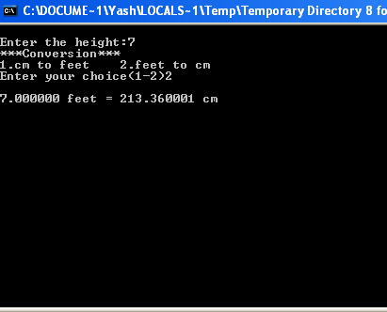

**//program to print ASCII value of a character**

#include<stdio.h>

#include<conio.h>

int main()

{

char k,ascii;

printf("\nEnter a key from keyboard:");

scanf("%c",&k);

printf("ASCII value of %c = %d",k,k);

getch();return 0;

}

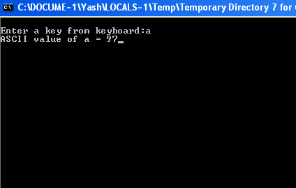

**//SI**

#include<stdio.h>

#include<conio.h>

void main()

{

float prin_amt,roi,time;

clrscr();

printf("\nenter Principal Amount,Rate of Interest and Time :");

scanf("%f%f%f",&prin_amt,&roi,&time);

printf("Simple Interest = %f",(prin_amt*roi*time)/100);

getch();

}

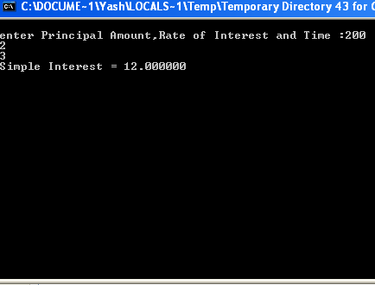

**//decimal to binary**

#include<stdio.h>

#include<conio.h>

void main()

{

int dec=0,a,i=0,bin[20],j,n,base=1;int ch;

clrscr();

printf("\n***CONVERSION***\n");

printf("1.Decimal to Binary\t2.Binary to Decimal\n");

printf("\nEnter your choice :");

scanf("%d",&ch);

if(ch==1)

{

printf("\nEnter a decimal number\n");

scanf("%d",&dec);

printf("\nBinary equivalent of decimal number is ");

while(dec!=0)

{

bin[i]=dec%2;

dec=dec/2;

i++;

}

for(j=i-1;j>=0;j--)

printf("%d",bin[j]);

}

if(ch==2)

{

printf("\nEnter a binary number\n");

scanf("%d",&n);

printf("Decimal equivalent is");

while(n!=0)

{

a=n%10;

n=n/10;

dec=dec + a * base;

base=base *2;

} printf(" %d ",dec);

}

getch();

}

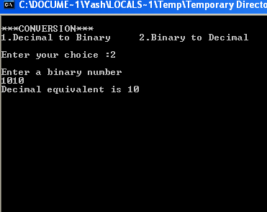

**//sum of digits**

#include<stdio.h>

#include<conio.h>

void main()

{

int d,n,sum=0;

clrscr();

printf("\nEnter a number:");

scanf("%d",&n);

while(n!=0)

{

d=n%10;

sum=sum+d;

n=n/10;}

printf("\nSum of digits:%d\n",sum);

getch();}

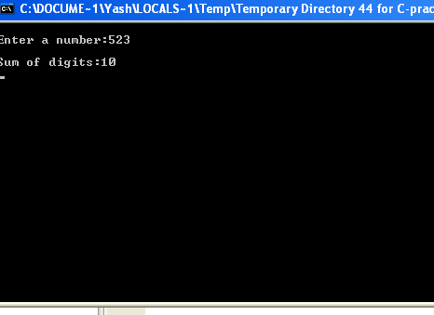

**//reverse a number**

#include<stdio.h>

#include<conio.h>

void main()

{

int d,n,rev=0;

clrscr();

printf("\nEnter a number:");

scanf("%d",&n);

while(n!=0)

{

d=n%10;

rev=(rev*10)+d;

n=n/10;}

printf("\nreverse of number:%d\n",rev);

getch();}

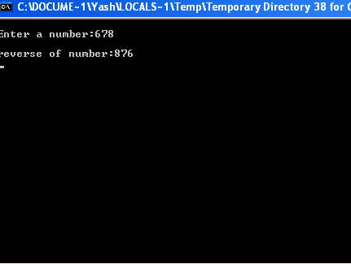

**//roots of equation**

#include<stdio.h>

#include<conio.h>

#include<math.h>

void main()

{

float a,b,c,d,r1,r2,r3;

clrscr();

printf("\nEnter a,b,c in a quadratic equation:");

scanf("%f%f%f",&a,&b,&c);

d = (b*b)-4*a*c;

printf("\nD=%f",d);

if(d==0)

{

printf("\nQuadratic Equation have Real and Equal Roots\n");

r1=-b/(2*a);

r2=r1;

printf("Roots : %f,%f",r1,r2);

}

else if(d>0)

{

printf("\nQuadratic Equation have Real and Unequal Roots\n");

r1=(-b+sqrt(d))/(2*a);

r2=(-b-sqrt(d))/(2*a);

printf("Roots : %f,%f",r1,r2);

}

else

{ printf("\nQuadratic Equation have Imaginary and Unequal Roots\n");

d=abs(d);

r1=-b/(2*a);

r2=-sqrt(d)/(2*a);

r3=sqrt(d)/(2*a);

printf("Roots : %f,%fi,%fi " ,r1,r2,r3);

}

getch();

}

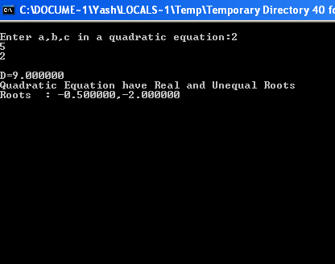

**//program to check an alphabet is vowel or consonant.**

#include<stdio.h>

#include<conio.h>

void main()

{

char ch;

printf("\nEnter an alphabet:");

scanf("%c",&ch);

if(ch=='A'||ch=='a'||ch=='E'||ch=='e'||ch=='I'||ch=='i'||ch=='O'||ch=='o'||ch=='U'||ch=='u')

printf("%c is a vowel",ch);

else

printf("%c is a consonant",ch);

getch();

}

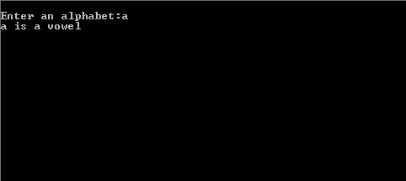

**//lcm and gcd**

#include<stdio.h>

#include<conio.h>

void main()

{

int n1,n2,i=1,minMul,gcd;

clrscr();

printf("\nEnter two numbers:");

scanf("%d%d",&n1,&n2);

minMul=n1>n2?n1:n2;

while(1)

{

if(minMul%n1==0 && minMul%n2==0)

break;

minMul++; }

printf("\nL.C.M of %d,%d is :%d",n1,n2,minMul);

for( ;i<=n1 && i<=n2;++i)

{ if(n1%i==0 && n2%i==0)

{ gcd=i;}} printf("\nH.C.F of %d,%d is :%d",n1,n2,gcd);

getch();}

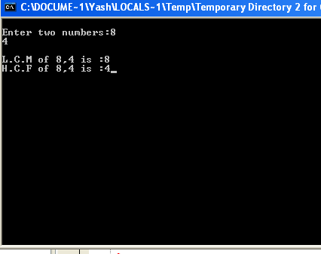

**//checking points in circle**

#include<stdio.h>

#include<conio.h>

#include<math.h>

int main()

{

int x,y,d,r,h,k;

printf("\nEnter the x,y coordinates of point:");

scanf("%d%d",&x,&y);

printf("\nEnter radius:");

scanf("%d",&r);

printf("\nEnter the h,k coordinates(centre of circle)");

scanf("%d%d",&h,&k);

d=pow(x-h,2)+pow(y-k,2);

if(d==r*r)

printf("\npoint lies on the circle");

else if(d<r*r)

printf("\npoint lies inside the circle");

else

printf("\npoint lies outside the circle");

getch();return 0;

}

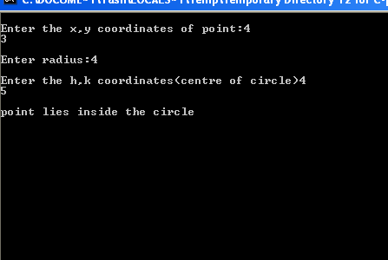

**//gp series sum**

#include<stdio.h>

#include<conio.h>

#include<math.h>

int main()

{

int i,n,a,r;

float sum=0.0;

printf("Enter the value of a: ");

scanf("%d",&a);

printf("Enter the value of r: ");

scanf("%d",&r);

printf("Enter the value of n: ");

scanf("%d",&n);

for(i=1; i<=n; i++)

{ sum=(a*pow(r,(n-1))); }

printf("%f",sum);}

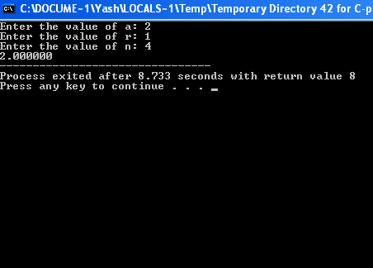

**//checking square of a number and its reverse number**

#include<stdio.h>

#include<conio.h>

int reverse (int num)

{

int rev = 0, mod;

while (num > 0)

{

mod = num % 10;

rev = (rev * 10) + mod;

num = num / 10;

}

return rev;

}

int main()

{

int n, i, num, rev, num_sq, rev_sq;

printf("Result:\n");

for (i = 0; i < 1000; i++)

{

num = i;

rev = reverse(num);

num_sq = num * num;

rev_sq = rev * rev;

if (num_sq == reverse(rev_sq))

{

printf("square of %d is %d\n", num, num_sq);

printf("square of %d is %d\n", rev, rev_sq);

}

}

return 0;

}

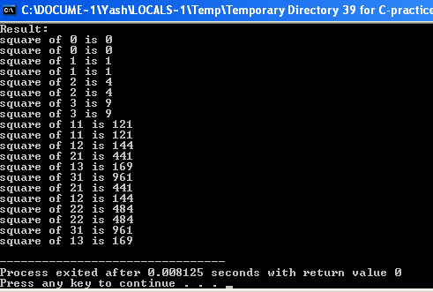

**//no.of days b/w two dates**

#include<stdio.h>

#include<conio.h>

void days(int,int,int,int,int,int);

int month(int,int);

int mon[12]={31,28,31,30,31,30,31,31,30,31,30,31};

int main()

{

int a1,b1,c1,a2,b2,c2;

printf("Enter first date(dd mm yyyy) : ");

scanf("%d%d%d",&a1,&b1,&c1);

printf("\nEnter second date(dd mm yyyy) : ");

scanf("%d%d%d",&a2,&b2,&c2);

if(c2>=c1)

days(c1,c2,b1,b2,a1,a2);

else

days(c2,c1,b2,b1,a2,a1);

getch();

}

void days(int y1,int y2,int m1,int m2,int d1,int d2)

{

int count=0,i;

for(i=y1;i<y2;i++)

{

if(i%4==0)

count+=366;

else

count+=365;}

count-=month(m1,y1);

count-=d1;

count+=month(m2,y2);

count+=d2;

if(count<0)

count=count*-1;

printf("The no. of days b/w the 2 dates = %d days",count); }

int month(int a,int yy) {

int x=0,c;

for(c=0;c<a-1;c++) {

if(c==1)

{ if(yy%4==0)

x+=29;

else

x+=28;}

else

x+=mon[c];}}

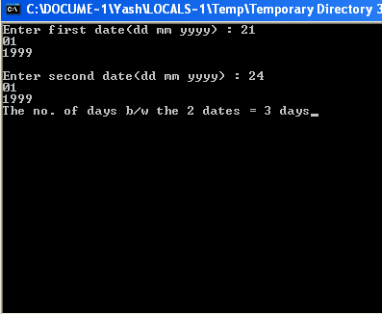

**//pythgorian triplet**

#include<stdio.h>

#include<conio.h>

int main()

{

int initial,final,a,b,c;

printf("Enter the range in which you want to search for Pythagorean Triplets:\nInitial: ");

scanf("%d",&initial);

printf("\nFinal: ");

scanf("%d",&final);

printf("The Pythagorean Triplets in the given range are as follows:\n");

for(a=initial;a<=final;a++)

{

for(b=a;b<=final;b++)

{

for(c=b;c<=final;c++)

{

if(c*c==a*a+b*b)

{

printf("%d , %d , %d\n",a,b,c);}}}}}

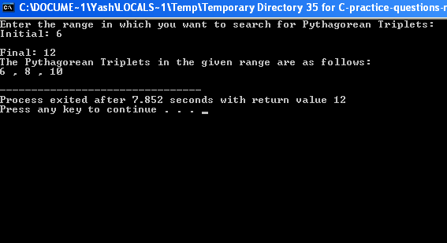

**//digits into words**

#include<stdio.h>

#include<conio.h>

int main()

{

int num,r,sum=0;

printf("Enter the number: \n");

scanf("%d",&num);

while(num>0)

{

r=num%10;

sum=sum*10+r;

num=num/10;

}

num=sum;

while(num>0)

{

r=num%10;

switch(r)

{

case 1:

printf("One \n");

break;

case 2:

printf("Two \n");

break;

case 3:

printf("Three \n");

break;

case 4:

printf("Four \n");

break;

case 5:

printf("Five \n");

break;

case 6:

printf("Six \n");

break;

case 7:

printf("Seven \n");

break;

case 8:

printf("Eight \n");

break;

case 9:

printf("Nine \n");

break;

default:

printf("Zero \n");

num=num/10;}}

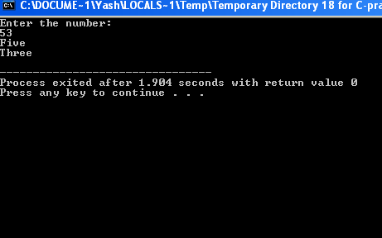

**//day of week**

#include<stdio.h>

#include<conio.h>

int dayofweek(int d, int m, int y)

{

static int t[] = { 0, 3, 2, 5, 0, 3, 5, 1, 4, 6, 2, 4 };

y -= m < 3;

return ( y + y/4 - y/100 + y/400 + t[m-1] + d) % 7;

}

/* Driver function to test above function */

int main()

{

int day = dayofweek(06, 10, 2019);

printf("The day is: \n");

switch(day)

{

case 1:

printf("Monday");

break;

case 2:

printf("Tuesday");

break;

case 3:

printf("Wednesday");

break;

case 4:

printf("Thursday");

break;

case 5:

printf("Friday");

break;

case 6:

printf("Saturday");

break;

default:

printf("Sunday");

break;

}

return 0;

}

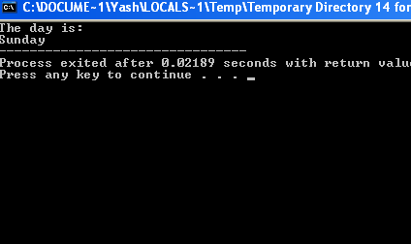

**// a) expansion series**

#include<stdio.h>

#include<math.h>

int fact(int n)

{

if(n==0) {

return 1;

}

int s=n*fact(n-1);

return s;}

int main()

{int x,n;

printf("Enter the value of x: ");

scanf("%d",&x);

printf("Enter the value of n: ");

scanf("%d",&n);

int sum=0;

for(int i=2; i<=n; i++)

{ sum+=pow(x,i)/fact(i);}

printf("The sum is: %d",(1-sum));}

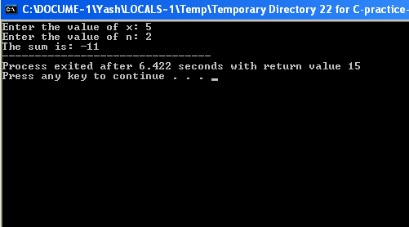

**//table for XY+Z**

#include<stdio.h>

#include<conio.h>

void main()

{ printf("Truth Table \n");

printf("X \t Y \t Z \t \t XY+Z \n \n");

for(int i = 0 ; i<=1 ; i++)

for(int j = 0; j<=1; j++)

for(int k = 0; k<=1; k++)

{

printf("%d \t %d \t %d \t \t",i,j,k);

if( (i == 1 && j == 1) || k == 1)

printf("0");

else

printf("1");

printf("\n"); }}

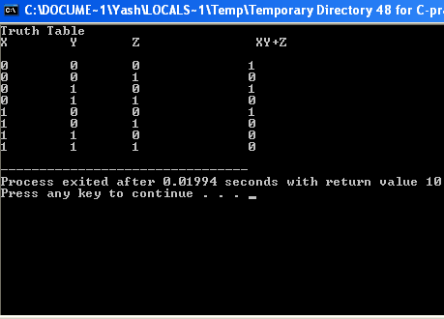

**//program for profit loss**

#include<stdio.h>

#include<conio.h>

int main()

{

int sp,cp,profit,loss;

printf("Please enter the selling price of the item: ");

scanf("%d",&sp);

printf("Please enter the cost price of the item: ");

scanf("%d",&cp);

profit=sp-cp;

if(profit>0)

{

printf("You have profit of %d:",profit);}

else if(profit==0) {

printf("You have neither incurred loss nor profit"); }

else

printf("You have incurred a loss");}

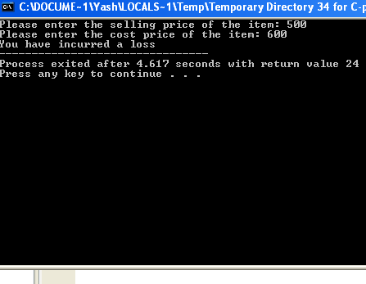

**//checking character**

#include<stdio.h>

#include<conio.h>

int main()

{

char c;

printf("Enter a character: ");

scanf("%c",&c);

if(c>=65 && c<=90)

printf("The character is an upper case letter");

else if(c>=97 && c<=122)

printf("The character is a lower case letter");

else if(c>=48&&c<=57)

printf("The character is a digit");

else

printf("The character is a special case letter"); return 0;

}

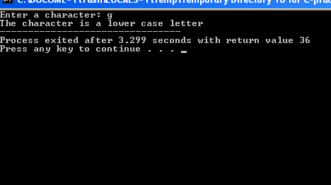

**//checking multiple or not**

#include<stdio.h>

#include<conio.h>

int main()

{

int n1,n2;

printf("Enter two digits:\n");

scanf("%d %d",&n1,&n2);

if(n1%n2==0)

printf("%d is a multiple of %d",n1,n2);

if(n2%n1==0)

printf("%d is a multiple of %d",n2,n1);

}

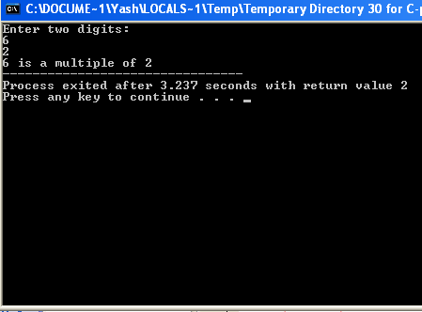

**//lower case to upper case**

#include <stdio.h>

#include <string.h>

int main() {

char s[100];

int i;

printf("\nEnter a string : ");

gets(s);

for (i = 0; s[i]!='\0'; i++)

{

if(s[i] >= 'a' && s[i] <= 'z')

{

s[i] = s[i] - 32;

}

else

{

s[i] = s[i] + 32;

}

}

printf("\n String is = %s", s);

return 0;

}

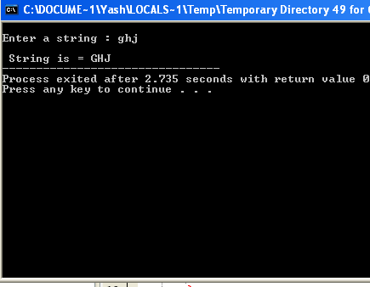

**//descending order number**

#include<stdio.h>

#include<conio.h>

int main()

{

int a[10];

printf("Enter the values into the array:\n");

for(int i=0; i<10; i++)

{

scanf("%d",&a[i]);

}

printf("The array is:\n");

for(int i=9; i>=0; --i)

{

printf("%d\n",a[i]);

}

}

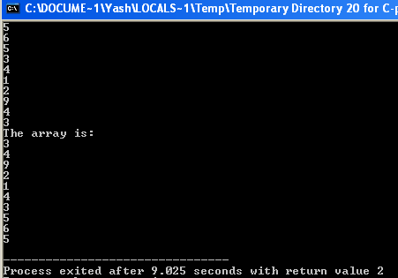

**//calculator**

#include<stdio.h>

#include<conio.h>

void main()

{

int a,b,ch,res=0;

clrscr();

printf("\n***MENU***\n");

printf("1.Addtion\t2.Subtraction\t3.Multiplication\t4.Division\n");

printf("Enter your choice(1-4)\n");

scanf("%d",&ch);

printf("\nEnter two numbers:\n");

scanf("%d%d",&a,&b);

switch(ch)

{

case 1: res=a+b;

printf("\nAddition : %d",res);

break;

case 2: res=a-b;

printf("\nSubtraction : %d",res);

break;

case 3: res=a*b;

printf("\nMultiplication : %d",res);

break;

case 4: res=a/b;

printf("\nDivision : %d",res);

break;

default: printf("Wrong Choice entered"); } getch(); }

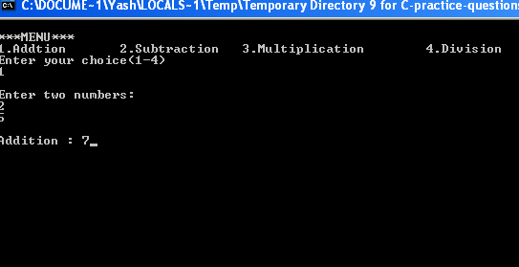

**//area of figures**

#include<stdio.h>

#include<conio.h>

int main()

{

int choice;

printf("Enter 1 for the area of a circle,\n 2 for area of rectangle,\n 3 for area of triangle,\n 4 for wrong choice: \n");

scanf("%d",&choice);

int r, l,b,h,b1,rect;

double circle,tri;

switch(choice)

{

case 1:

printf("Enter the radius: ");

scanf("%d",&r);

circle=(double)3.14*r*r;

printf("Area of the circle is: %f",circle);

break;

case 2:

printf("Enter the length and breadth:\n");

scanf("%d %d",&l,&b);

rect= l*b;

printf("Area of the rectangle is: %d",rect);

break;

case 3:

printf("Enter the height and base:\n");

scanf("%d %d",&l,&b1);

tri=(double) 0.5*h*b1;

printf("Area of triangle is: %f", tri);

break;

default:

printf("Wrong choice");

}

}

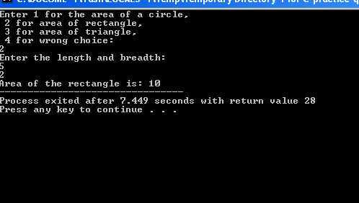

/**/divisibility by 5 or 3**

#include<stdio.h>

#include<conio.h>

int main()

{

int num1,num2,sum=0;

printf("Enter the value of num1 and num2: \n");

scanf("%d %d",&num1,&num2);

printf("The sum is: ");

for(int i=num1; i<=num2; i++)

{

if(i%2==0)

{

if((i%5!=0)&& (i%3==0))

{

sum=sum+i;

}

}

}

printf("%d",sum);

}

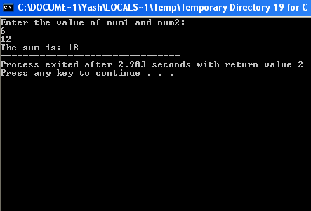

**//calculate exponent**

#include<stdio.h>

#include<conio.h>

#include<math.h>

int myExpo(a,b){

int power=pow(a,b);

printf("The power is %d",power);

}

int main()

{

int a,b;

printf("Enter the value of a and b \n");

scanf("%d %d",&a,&b);

myExpo(a,b);

return 0;

}

**//caluclator**

#include<stdio.h>

#include<conio.h>

int main()

{

char n;

int a,b,sum,diff,mul,mod;

double div;

printf("Enter + in case of addition,\n - for subtraction, \n * for multiplication, \n mod for remainder, \n / for division: \n");

scanf("%c",&n);

printf("Enter the value of a and b: \n");

scanf("%d %d",&a,&b);

switch(n)

{

case '+':

sum=a+b;

printf("The sum is: %d",sum);

break;

case '-':

diff=a-b;

printf("The difference is: %d",diff);

break;

case '*':

mul=a*b;

printf("The product is: %d",mul);

break;

case '%':

mod=a%b;

printf("The remainder is: %d",mod);

break;

case '/':

div= (double) a/b;

printf("The division is: %f",div);

break;

default:

printf("Invalid option");

}

}

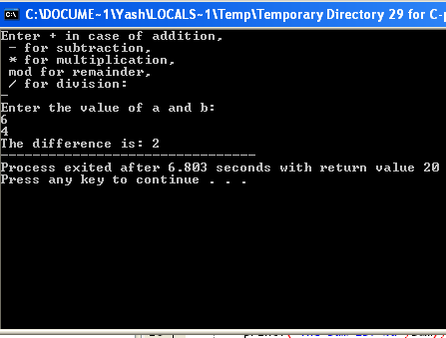

**//fact sum**

#include<stdio.h>

#include<conio.h>

#include<math.h>

int fact(int a)

{

return(a*fact(a-1));}

int main()

{ int i,n,j;

float sum=0.0;

printf("Enter the value of n: ");

scanf("%d",&n);

for(i=1; i<=n; i++)

{

sum+=1/fact(i);

}printf("%f",sum);

}

